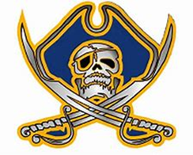
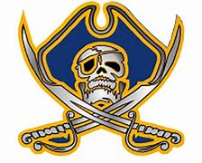
CRHS Marching Band
2021 Performance Schedule
*All performances are tentative and are subject to change*
Date Performance Location Time
8/20/21 FBG v. New Smyrna CRHS 7:00p
8/27/21 FBG @ South Sumter South Sumter High 7:00p
9/3/21 FBG @ Villages Villages High 7:00p
9/10/21 FBG v. Belleview CRHS 7:00p
9/17/21 FBG @ Dunnellon Dunnellon 7:00p
9/24/21 FBG v. Springstead CRHS 7:00p
10/1/21 FBG v. Lake Weir CRHS 7:00p
10/2/21 University High Competition University High TBA
10/8/21 FBG @ Lecanto Lecanto High 7:00p
10/9/21 Durant High Competition Durant High TBA
10/15/21 FBG v. Citrus CRHS 7:00p
10/16/21 Wiregrass Ranch Competition Wiregrass Ranch High TBA
10/21/21 FBG v. South Lake CRHS 7:00p
10/23/21 Tarpon Springs Competition Tarpon Springs High TBA
10/29/21 FBG v. Leesburg CRHS 7:00p
11/6/21 Marching MPA TBA TBA
11/11/21 Veteran’s Day Parade Inverness TBA
11/13/21 North Marion Competition North Marion High TBA
11/20/21 FMBC (Semi)Finals Ocala Equestrian Center TBA
12/4/21 Crystal River Christmas Parade Crystal River TBA
*Call times are to be determined closer to the event*
Competitions are all-day events, so please plan accordingly.

